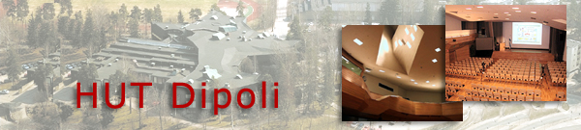


A proposal to host

CoNEXT 2006

in

FINLAND

by

Helsinki University of Technology
and
Tampere University of Technology
Key Facts
Hosts: | Helsinki University of Technology  Tampere University of Technology
Venue: | Conference Center Dipoli at Otaniemi, Espoo
Dates: | From 1st to 4th August 2006 or 4th to 7th September 2006
Accommodation: | Hotel Radisson SAS Espoo
Travel: | Helsinki/Vantaa Airport

Facts about HUT:
Helsinki University is the leading technical university in Finland. It was founded in 1849 and received university status in 1908. HUT has twelve faculties, ten separate institutes, 17 degree programs. The amount of students in HUT varies around 14000 of which 940 Masters´ degrees and 195 doctorates were awarded in 2002. Total funding from state and other sources in 2002 was 189 million euros.
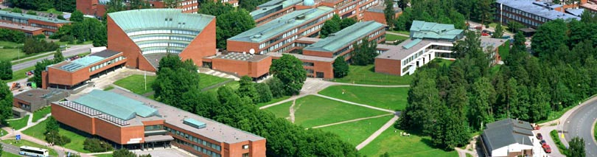

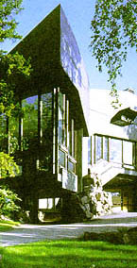
Facts about location and venue:
Conference venue is located at the heart of HUT campus in Otaniemi, Espoo. HUT campus area is a combination of university atmosphere, national research institutes and small innovative technology companies. Conference center Dipoli is a separate HUT institute concentrating on life long learning, exhibitions and conference organization. Building has large number of meeting rooms with modern meeting facilities. Catering is provided by in house restaurant which has long tradition on organizing catering for large meetings.

Facts about travel and accommodation:
HUT campus is situated on western side of the capital area. To be slightly outside the heart of the capital offers good connections from and back to the Helsinki/Vantaa airport situated on the northern side of the capital area. With taxi it takes roughly 30 minutes to the airport. Helsinki/Vantaa airport is the main national airport in Finland, serving direct connections to all main airports in Europe and the world. Public transportation in the capital area is well organized. Large variety of busses and trains serve the capital area. A bus from the HUT campus area to the city center goes every five to ten minutes. Conference hotel is located at the campus. Radisson SAS Espoo is a seaside hotel at the edge of the campus, only 150 meters away from the venue. There are additional hotels at the close vicinity of the conference venue (2-5 km from the Dipoli).
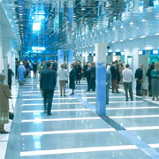

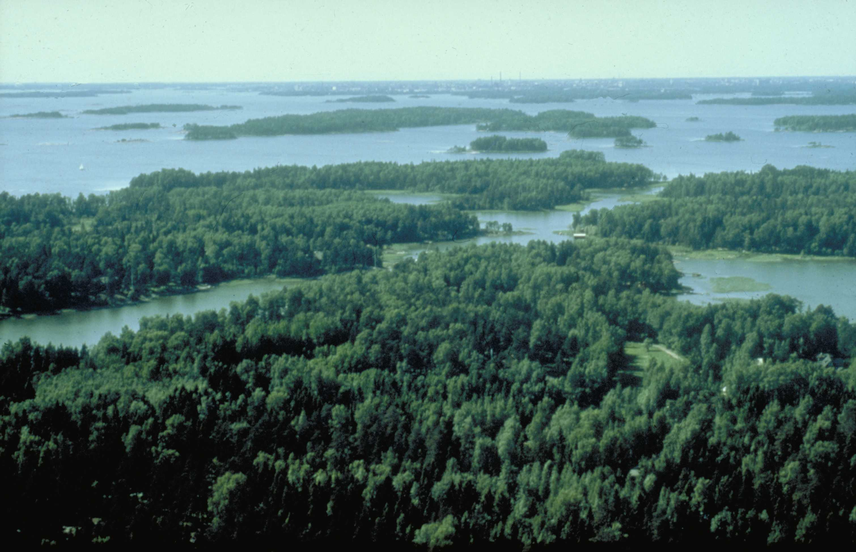
For companions
Capital area offers large variety of museums and galleries to see. Old fortress outside Helsinki offers a good atmosphere for a picnic. There is also large untouched wilderness area near the conference venue at Espoo. Sea, which surrounds conference area, offers almost unlimited opportunities – to spend a day on a cruise or even take a ride with luxurious ferries from Helsinki to Stockholm or to Tallinn. Helsinki has, in general, good weather conditions to the late September.

Links:
- HUT: www.hut.fi/English/
- HUT campus area: www.otaniemi.com
- Conference Center Dipoli: www.dipoli.hut.fi/kongressipalvelut/english/index.html

