Mobile Virtual Network Operators:
"One doesn’t need to own a cow to milk a cow”
Timo Smura
timo.smura@iki.fi

Mika Marjalaakso
mika.marjalaakso@iki.fi

Abstract
This paper introduces the business concept of Mobile Virtual Network Operators (MVNO), who buy wholesale network capacity from a Mobile Network Operator (MNO) to obtain essentially the same possibilities to offer mobile services to end-users.
These new players have just recently entered the mobile business space. They come from different backgrounds ranging from multinational consumer brands to media companies, and implement strategies that differ from the strategies implemented by traditional MNOs. The ongoing deregulation activities have significantly lowered barriers to entry – the initial investment to the network infrastructure, for instance, is 80% lower for a MVNO as compared to a MNO. In Finland there are already 10 MVNOs that are either active or just starting up their business.
The objective of the paper is to look for common denominators for the heterogeneous MVNOs, and to analyse some strategic options they can choose. This knowledge is used as a basis for development suggestions to the Mobile Operator Business (MOB) game developed in the Helsinki University of Technology.
The scope of this paper is on mobile operator business in Finland. Strategies outside this scope are not discussed.
Key words:
Mobile Virtual Network Operator (MVNO), Mobile Network Operator (MNO), Mobile Virtual Network Enabler (MVNE), service operator, network operator

Introduction

Background
The huge mass market of mobile communications is in turmoil. Introduction of pre-paid services has lead to a strong increase in mobile market penetration in Western Europe (approx. 70% penetration) [1]. In Nordic countries, especially in Sweden and Finland, the mobile market is reaching its saturation point (approx. 90%).
At the same time, the nature of the mobile market is changing rapidly. The convergence of telecom networks and services, and the evolution towards all-IP networks is pushing all kinds of applications, services, and content to IP-based networks – including mobile networks and terminals. The increased technology push for high-speed data services, and particularly the advent of always-on, high bandwidth, and reasonably priced mobile data connections will facilitate the introduction of whole new generation of services.
The regulatory environment is changing, as well. The European Union is continuing its efforts to increase competition in the whole EU area. The communications directives, issued by EU, are aiming at changing the telecommunications regulatory framework so that basically every interested player could start offering mobile services without owning the network or rights to the required radio spectrum. This set up has interesting implications. The MVNOs must either run their operations more cost-efficiently or provide value added services in order to be competitive against MNOs. Most MVNOs have chosen the former option. As a result of harsh competition, there have already been sharp cuts in the pricing of mobile voice services – currently the most important source of mobile revenues.
The Average Revenue Per User (ARPU) is declining due to the declined price of voice services and the success of pre-paid. This phenomenon is expected, or at least hoped, to be set off with the introduction and adoption of new, more expensive data services such as mobile internet in the near future. The emphasis is on the words “near future” as today MNOs, many burdened by heavy financial investments in 3G, are struggling to keep their customers in a competition with low-cost performing MVNOs.
Becoming a MVNO might prove to be a huge opportunity. In a way, the MVNOs present a serious risk to MNOs by speeding up the decline in the pricing of basic services. On the other hand, MVNOs with high brand value and large customer base present an opportunity to capture, for instance, market share from a competing MNO. MNOs can also reduce their risks in 3G network infrastructure investments by partly sharing expenses with MVNOs.

The MVNO Opportunity
The size of the MVNO market in Europe is expected to grow substantially in the following years, as indicated in Figure 1. Entering into MVNO business presents a huge opportunity for companies with appropriate resources to leverage on.
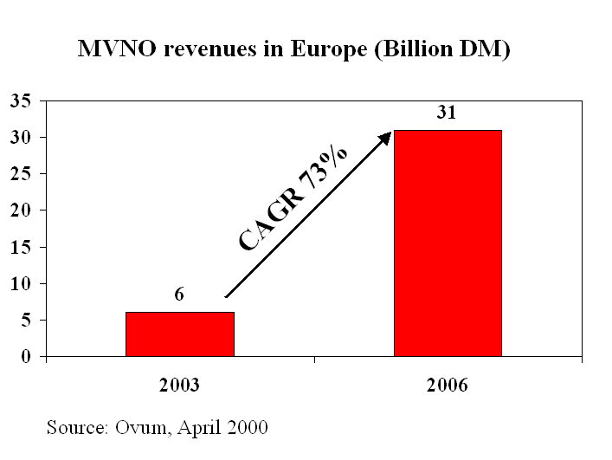
Figure 1: MVNO revenues in Europe
Virgin Mobile is an example of a successful MVNO without prior telecom expertise. It possesses a strong brand, a distribution network and an attractive content- and service-portfolio. It was the first consumer brand to launch into UK market on November 1999 hosted by One to One network. Latest key figures (referenced 5.11.2003) from their web pages indicate remarkable success [2]:
- 269, 681 net connections in Q3 2003
- Total customer base 3,183,347 (30th Sept. 2003)
- Customer growth up 56% since Q3 2002 (2,013,382)
- Record Q3 2003 turnover of £112,6m
- Nine month EBITDA of £67m
- Nine month operating profit of £59m
- Nine month turnover of £309m

The personnel exceeding 1500 people and over 6000 distribution outlets gives an idea on the size and scope of Virgin’s operations.

Business environment and MVNOs in Finland

Mobile value chain
Figure 2 depicts the value chain of the mobile operator business.

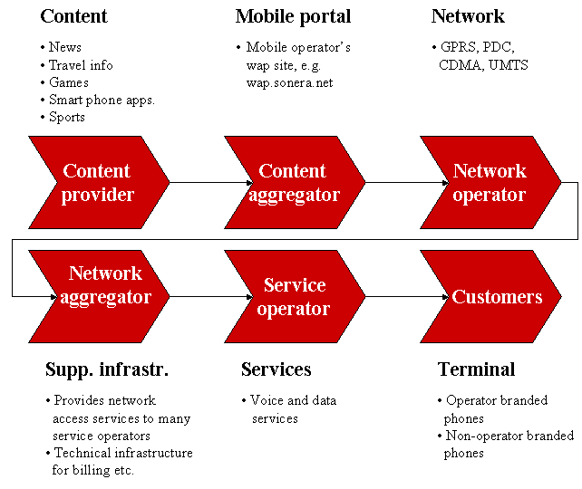
Figure 2: Mobile value chain
In the figure, the key players and their roles in the value chain are shown. The terminology used varies considerably between different sources. For example, the terms MNO, MVNE (Mobile Virtual Network Enabler), and MVNO, are used instead of network operator, network aggregator, and service operator, respectively. These terms are examined more closely in the following subchapters.

Legislation
The division of telecommunications operators to network and service operators is based on the EU legislation. In Finland, the Communications Market Act [3] of 2003 gives the following definitions:
Network operator means an operator that provides a communications network in its ownership or for other reasons in its possession for the purposes of transmitting, distributing or providing messages.
Service operator means an operator that transmits messages over a communications network in its possession or obtained for use from a network operator or distributes or provides messages in a mass communications network.
One of the key goals of telecommunications regulation is to obligate network operators to lease out capacity from their networks to all service operators at a fair price. This fair price should reflect the appropriate investment and operating costs, and offer modest return on the investment.. In this regulatory framework, the concept of significant market power (SMP) plays a major role. Operators declared to have SMP in a certain market, are obliged to relinquish access rights to their networks, antenna sites and equipment facilities, and to publish the related delivery terms and tariffs. Furthermore, the SMP operators are obliged to separate the network operator and service operator functions of their businesses, at least in the accounting level. This allows for the regulator to decide whether the tariffs of network operators are actually reflecting the costs.

MNOs and MVNOs
In the mobile operator industry, the terms service operator and network operator are not very commonly used. Instead, the operators are often divided to Mobile Network Operators (MNOs) and Mobile Virtual Network Operators (MVNOs). The MNOs are operators that own a spectrum license, and operate a complete network infrastructure. The concept of MVNOs, on the other hand, is not unambiguous.
ITU defines MVNO as an operator that offers mobile services but does not own its own radio frequency [4]. The MVNOs are often further divided into subcategories, based usually on the amount of network components owned and operated by the MVNO. Often, three different mobile service operators are divided into three groups: service providers, enhanced service providers, and “full” MVNOs. This division, based on the make-or-buy decisions of a service operator, is illustrated in Figure 3.
Figure 3: MVNO types [5]
The Finnish MVNOs fall into the service provider and enhanced service provider categories. In this paper, the term MVNO refers to all these three categories as a whole.

Potential entrants' background
Before the advent of MVNOs, the mobile operators had their roots in the fixed line telephony. The MVNO concept, however, allows new kinds of players to enter the market. Existing network infrastructure is not a defining factor anymore. Instead, companies with strong brands and extensive distribution networks have good chances to succeed in the market. Figure 4 shows some examples of industries that might get involved in the MVNO business in the forthcoming years. [1]

Figure 4: MVNOs' backgrounds [1]
The key success factors for a potential entrant include the following:
- Bringing innovative value added content, services and applications to the market
- Offering high customer orientation and high service quality
- Utilizing an existing customer bases and using it effectively for diversification into other businesses
- Having access to a large distribution network
- Having sufficient financial capacity.

MNOs and MVNOs in Finland
In a specific market, the number of spectrum licenses available for mobile services ultimately limits the number of MNOs. In Finland, three operators have licenses for GSM, and four for the emerging UMTS systems. The main players, Sonera, Radiolinja, and Finnet Group have licenses for both GSM and UMTS. In addition, the Sweden-based Tele2 has a license for UMTS systems.
Because of the regulatory framework, each player has incorporated their service operator and network operator businesses in separate subsidiaries.
The Finnish mobile operator landscape is shown in Figure 5.
Figure 5: MNOs and MVNOs in Finland
In the figure, the MNOs, consisting of a network operator and a service operator, are highlighted. Furthermore, each MVNO is placed under the network operator from which they lease the network capacity and related services.
The Finnish MVNOs are studied further in Chapter 4.

MVNO business strategies
In the following, some high-level business strategies of MVNOs are introduced. The discussion excludes niche strategies, as they are not relevant from the MOB business game point of view.
In mobile communications, at least three different sources of revenue can be identified: 1) subscription and usage fees, 2) advertising income, and 3) m-commerce. A potential, new MVNO entrant may view mobile communications market as a lucrative business itself by making profit through offering services (subscription and usage fees), or have focus on e.g. cross-selling opportunities via high control of a new type of distribution channel (m-commerce). This chapter focuses on MVNOs interested at offering services to the mobile market.

Communications and value added services
The services offered for customers can be categorized into two groups: communications and value added services.
Most of the services offered and charged in today’s marketplace are communications services. Communications services are about providing facilities for people, machines, and systems to interchange information – to communicate. It’s truly about selling bits or capacity. These services include e.g. voice, multimedia (video real-time, video telephony), messaging low volume (SMS, chat, email without appendix), messaging high volume (e-mails with attachments, e.g. Powerpoint presentations, MP3 audio files) and telematics.
Value added services (VAS), on the contrary, provide added value to mere communications, and the services provisioning requires special know-how, applications, systems, and dedicated personnel. Examples of these services are information services, location-based services, m-commerce, m-entertainment, personal information management and internet/intranet access.
A choice, by MVNO, must be made whether to focus on communications services, value added services, or both. So far the market for value added services is almost non-existent. The focus in revenues is, however, predicted to shift towards value added services and content. Summary of ARPU projections (based on consultancy reports [5]) is presented in Table 1 below.

Table 1. Summary of ARPU projections [5]

Low cost strategy or excellence in services?
Whether a MVNO decides to offer communications, value added or both services, a higher-level business strategy must be selected. The basic options for the high level strategy are to build leadership in low costs, or excellence in services.. Both basic strategies can, in principle, be implemented with the complementary technology leader strategy.
Cost leader offers low cost services by implementing a business system that leads in highly cost-effective operations. Cost leaders service mix is expected to be rather small and targeted mainly for price sensitive consumers, and perhaps to small and medium-sized businesses. The value offered is in low fares, adequate service quality, and simple pricing schemes. The aim is to minimize the number of personnel and use internet-based operations extensively.
Cost leaders must focus on providing a limited set of services for a set of target customers in order to achieve lower costs by optimizing their business system. Business systems can not be optimized for providing everything to everyone.
Service leader focuses on offering high quality service for demanding customers. Their service mix should be rather large as demanding customers, especially businesses, expect to get all the services they need from a one shop. Service leaders aim to maximize cross-selling opportunities arising from their broad service portfolio offered for many different type of customers. The sales function is organized by customer type. The value offered is in high reliability, and meeting a wide variety of customer’s needs and therefore minimizing transaction costs.
Technology leader, as said before, is not an independent strategy option but can be coupled with cost or service leader strategy. For cost leader, being a leader in technology, means capitalizing on newest technology and systems that enable more cost-efficient operations than competitors are able to achieve. Service leader implementing technology leader strategy can also benefit from increasing productivity but the emphasis is more on developing technologies and competencies that enable offering of new services earlier than competitors. This may, at the end of the day, result in higher market share due to first mover advantages.
Implementing technology leader strategy implies higher investments in technologies development and acquisition, and related personnel.

MVNO strengths and weaknesses
The MVNO opportunity lies in the ability to make more money by leveraging on existing assets such as brand and customer base. Among the biggest threats is the inability to be competitive against existing MNOs due to unfair interconnect pricing, and margin cuts due to increased competition.
Below we have summarized the most important strengths and weaknesses of which a MVNO candidate may possess some or all depending on its background.
Strengths:
- large customer base with high customer loyalty and brand recognition, which can be used as an initial beach head for entering the market
- high number of suitable outlets for distribution (from national to worldwide coverage) of own services to target customers
- well-known mega-brand (e.g. Virgin) with high share of mind within the targeted customers
- excellence in creating and offering value added services for target customers
Weaknesses:
- lack of experience or no experience at all in running telco type of business operations
- lack of technical know-how on the possibilities and limitations of mobile networks
- longer time to market for services based on new technology than in the MNO's case.

Key issues
The attractiveness of a MVNO opportunity depends critically on three factors: infrastructure cost, route to market and interconnect cost [5].
The infrastructure cost is the investment and running cost of the network infrastructure equipment. This cost can be relatively high for a MVNO unable to receive high volume discounts as compared to existing MNOs. The level of infrastructure cost also depends on the extent to which MVNO wants to have control over network elements, and thus services it can offer.
Route to market costs comprise high initial marketing and customer acquiring costs.
Interconnect cost is the cost paid by MVNO to MNO for the usage of capacity in MNO’s network. This is the most important cost item that should be governed by the regulations. There are currently two distinct tariff models, discussed further in next subchapter, on how to determine the interconnect cost.
To summarize, for a starting MVNO, the two most important issues it must solve before entering the market are:
- How to negotiate commercially acceptable conditions for interconnect cost?
- How to quickly acquire customers while bearing high initial investments before reaching profitability?

‘Retail minus’ and ‘Costs plus’ interconnect cost tariff models
There are two different models for the pricing of network access and usage of MNOs resources.
‘Retail minus’ is preferred by the MNO. Prices are negotiated in secrecy between MNO and MVNO. This tariff model allows for low potential for margin of MVNO (30% of ARPU).
The other model, ‘Costs plus’, where the interconnection cost is governed by the regulator, is preferred by the MVNOs. The interconnect cost is calculated by adding reasonable margin to the capital invested by MNO to maintain and operate it's network infrastructure. This tariff model allows for high potential for margin of MVNO (50% of ARPU).

Modeling MVNO’s revenue and costs structures
For simulation purposes, we can define two different MVNO types: one that is pursuing cost leader and another that is pursuing service leader strategy. Both types have an advantage in serving specific customer groups. Different customer groups have specific needs, which must be fulfilled with distinct service mixes. The ability to offer customer group specific mixes requires both initial investment to the required infrastructure, and running operational costs. Both MVNO types must, of course, pay the interconnect cost to MNO, for the network capacity they resell while adding more or less own value.
The mechanism for determining the interconnect cost can be either ‘costs plus’ or ‘retail minus’ but it should be same for all the players within one country. The current regulatory situation in Finland supports the use of 'costs plus' model.
Implementing technology leader strategy together with cost or service leader strategy requires additional investments and increases operational cost, but may lead to first mover advantage when introducing new services to the mobile market.
The whole model is shown in Figure 6.

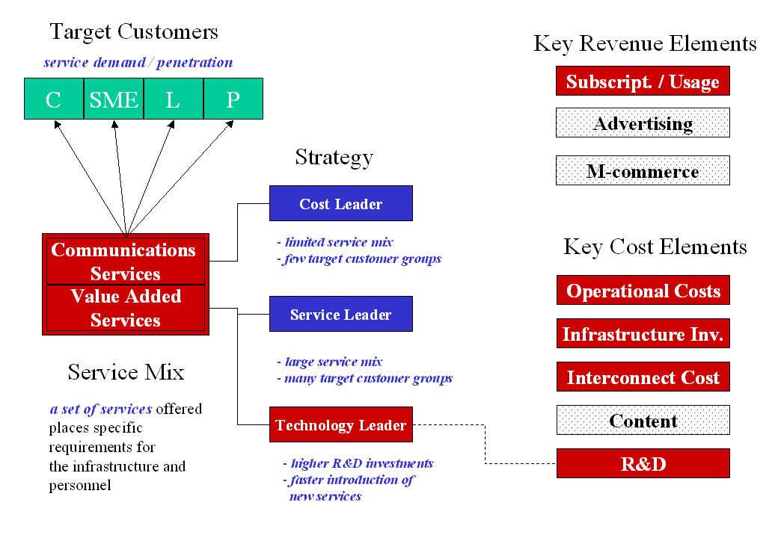
Figure 6: Model of MVNO's business elements

Analysis of selected MVNOs in Finland
As shown in Figure 5, there are already ten different companies in Finland that are offering, or are about to offer mobile services as MVNOs. In the following, a brief analysis is made on the most interesting cases.

Basic GSM services with Internet-based operations: Saunalahti and Cubio
A clear strategy of many MVNOs is to keep the operation and distribution costs in minimum, and offer basic, low-cost GSM services targeted mostly to consumers and SMEs. Saunalahti and Cubio are examples of such companies.
Saunalahti Group (former Jippii Group) is an Internet and teleoperations company, whose market area is Finland. In addition, the company offers mobile entertainment services in international markets.
Saunalahti has currently 189 employees (125 in the Internet and Teleoperator business area). The company has turned into profitable during 2003, after some heavy losses made in the past. The number of Saunalahti's GSM subscribers has grown from less than 30.000 to over 100.000 during the year 2003, benefiting greatly from the number portability demand. [6]
According to Saunalahti [7], it's main target groups in the GSM market comprise the youth, and people sending text messages frequently. As examples of the service offering, Saunalahti offers services named TiVKoR (text messages free of charge to five friends regardless of operator) and KpiKoR (call your friend for next to nothing regardless of operator). Saunalahti is also offering competitively priced subscriptions for SMEs. The service mix includes GPRS and MMS in addition to the basic GSM services. The company is competing strongly on price, and offers perhaps the least expensive GSM subscriptions in the market.
Saunalahti’s primary distribution channel is the Internet. Therefore, it has been able to maintain distribution costs at a relatively low level. Saunalahti's GSM subscriptions are also available at some computer, consumer electronics, and mobile phone stores. The company has also developed a special subscription that is distributed at Hesburger hamburger restaurants around Finland. Saunalahti has been actively advertising its services in newspapers, television, and Internet.
Cubio Communications Ltd is another example of a MVNO that targets consumers and SMEs using Internet as distribution channel. Cubio has been active as a fixed line operator, offering low-cost international voice and IP carrier services. The company started to offer basic GSM subscriptions as a MVNO in Radiolinja's network in April 2003.
Cubio's turnover in 2002 was 13 million euros, and it made a profit of about 0,5 million. The company is currently employing 30 persons [8]. The current number of Cubio GSM subscribers is unknown.
Cubio's target customer segments seem to be consumers and SMEs. The company is trying to distinguish itself with low prices and a complete service offering that includes GSM, national and international fixed line telephony, ADSL, and VPN services.

Full service IT houses: Fujitsu Services
Fujitsu Services (former Fujitsu Invia) is a completely different kind of MVNO compared to Saunalahti or Cubio. The company does not offer separate GSM subscriptions, but integrates them to a complete outsourced IT offering targeted mostly at large enterprises. Fujitsu introduced its GSM services in May 2003, and it is using Suomen 2G as its network operator.
Fujitsu Services is one of Finland's largest IT companies. It is currently employing 1700 persons in Finland, and has a turnover of about 300 million euros. The main product of the company is the Patja outsourcing and ASP service for enterprises, covering 60.000 workstations in Finland. [9]
The main target group of Fujitsu is enterprises. The GSM subscriptions are merely a part of a complete outsourcing offering covering the whole IT infrastructure and applications of a customer company. The marketing and distribution channel is therefore direct relationships with potential customers. Pricing of the GSM subscriptions depends on the case, and may vary between different customers.

Network marketing companies: PGOne and Terraflex
An interesting development in the mobile market is the use of network marketing channels in the distribution of GSM subscriptions. Two such companies have announced to start their businesses also in Finland. PGOne is operating as a MVNO in Suomen 2G's network, and Terraflex in Sonera's network.
PGOne Ab is a subsidiary of a Nordic enterprise Ventelo that owns also another subsidiary, Seven Ab. PGOne is responsible for the development and operations of mobile service business, whereas Seven is focused on the marketing network. The company has activities in Sweden, Norway, Finland, Denmark, and Italy. In Finland, the company is offering GSM subscriptions under the PGFree brand name.
PGOne's service mix includes basic GSM voice calls and SMS services. Thus, it is competing with lower prices, and offers e.g. a subscription with free 30-minute phone calls between PGOne subscribers. [10]
Terraflex Europe began its operations in Sweden in the beginning of 2001. In 2003, the company is expanding to Norway, Finland, Denmark, and the Baltic countries. The company offers GSM and SMS services, and also prepaid subscriptions. The pricing is very competitive, and as a special service, the first 30 seconds of any phone call between Terraflex subscribers are free.
In order to join the Terraflex marketing network no starting fees are required. An optional annual fee of 69€ is required for a personal web page for marketing purposes. Each network marketer must find at least 10 subscribers and 3 network marketers in order to be entitled to bonuses from the company. [11]
Network marketing –based companies usually have very little fixed assets, and are outsourcing also the customer care activities to third parties. The marketing and advertising expenditures are also low. The business is based on the low prices on basic services, and the negotiation and social skills of the network marketers. The bad reputation of network marketing companies as a whole can be seen as a weakness for these operators.

Other Finnish MVNOs
The other MVNOs in the Finnish marketplace include Tele2, Globetel, CDF Mobile, Wireless Maingate and Finnetcom.
Tele2 is a large Swedish fixed and mobile operator that has operations in many European countries. It also owns a spectrum license for UMTS systems in Finland. Tele2 has announced a MVNO contract with Radiolinja, and is expected to start offering GSM services until its 3G services are launched.
Globetel and CDF Mobile are small MVNOs, offering GSM services for consumers.
Wireless Maingate is specialised in machine-to-machine (M2M) communications solutions. As an MVNO, it is enabling legacy machines such as gas pumps to send GSM and SMS messages.
Finnetcom (former RSL Com) was actually the first Finnish MVNO to start its operations in 1999. Its target customers include only SMEs and large corporations. Interestingly, the company uses Sonera's network although the Finnet Group owns it.

Conclusions and suggestions

Conclusions

In the paper, a discussion on the backgrounds, strategies, and opportunities of Mobile Virtual Network Operators in Finland was presented. Some Finnish MVNOs were also briefly introduced.
The current mobile market seems to be attractive to MVNOs, and the possibilities to succeed in the competition against MNOs are good. At the moment, the competition on the market is strongly based on pricing, as the value-added services are not yet generating much revenue. In the future, the data services and different kinds of multimedia contents are expected to be the main source of revenue for operators and other players. The MNOs are supposedly in a better position in the provisioning of these, as they have a better knowledge on the possibilities and limitations of the new technologies, and are indeed controlling the launch of the new network infrastructure and service capabilities. On the other hand MNOs don’t know much about how to create, manage and make profits of content.
Most of the current MVNOs are striving for cost leadership and challenging the MNOs to price competition. In the future, more and more MVNOs are expected to focus on a certain customer segment, and offer a service mix that best fulfils the needs of that segment. This way, above-average pricing can be justified.

Suggestions for the MOB business game
The current version of the Mobile Operator Business (MOB) game developed in the Helsinki University of Technology does not have the ability to model or simulate the MVNO business. On the basis of this paperwork, some suggestions are made how the game could be further developed.
First of all, a decision should be made whether to model the MVNOs in the game simply as potential customers and/or competitors to the actual players (MNOs) of the game, or should it be possible for the players to take the role of a MVNO in the game.
In both cases, the interfaces between a MNO and MVNO must be defined. In the real world, there are many MVNO types, each having a certain amount of owned network infrastructure. In the game, however, it could be feasible to implement only one of these types. We suggest the Enhanced Service Provider –type of MVNO to be implemented, representing most of the actual MVNOs today.
In addition to the interfaces, the cash flows between the MNO and the MVNO have to be identified and defined. In this paper, these flows were not treated very thoroughly, as there is very little public information available. This is certainly an area for further study.
The modeling of the MVNO business in the MOB game might prove to be challenging, but it would improve the gaming experience substantially. It would be interesting to have at least some aspects of the MVNOs implemented in the game. Therefore, we suggest a three-level approach to the modeling:
  - One or more MVNOs are implemented in the game as competitors to the actual players. These MVNOs are implementing a cost leader strategy, and have significantly lower operational and capital expenditures compared to MNOs. The MVNOs have slower time-to-market with new services than the MNOs. No transactions are necessary between the MVNOs and the actual players (MNOs). The fixed interconnect cost is determined by the game operator.
  - The MVNOs are implemented as in the first case. Furthermore, the MVNOs choose one of the players (MNOs) as their network operator. The MVNOs could, for example, negotiate the deals with the MNOs, and choose the one with the lowest interconnection fees.
  - The actual players of the game can act also as MVNOs. A number of different MVNO types exist to be chosen from, e.g. the Enhanced Service Provider and the "full" MVNO. The MVNOs can drive cost or service leader strategies.

References
- Fraser, C.: Part IV, Mobile Virtual Network Operators, Eurescom Summit, 3G Technologies and Applications, Bonn, 2001

- Virgin Mobile web site, http://www.virginmobile.com/mobile/media_centre/media_intro.jsp

- Ministry of Transport and Communications, Finland, 2003. Communications Market Act. http://www.mintc.fi/www/sivut/dokumentit/viestinta/tavoite/communications_market_act.pdf

- Xavier, P., 2001. Licensing of Third Generation (3G) Mobile. Briefing paper for ITU Workshop on licensing 3G Mobile, 19-21 September 2001.

- Dimitris Katsianis (editor), many authors: Final results on economic viability of 3G MVNOs, published 28.6.2002, IST-2002-25172 TONIC (deliverable number 9)

- Saunalahti Group Oyj, Interim report Q3/2003. http://www.saunalahtigroup.com/bulletin.php?index=180

- Jippii Group, Annual Report 2002. http://www.saunalahtigroup.com/Vuosikertomus_Jippii_02_ENG.pdf

- Cubio Communications Ltd. Company web-site. http://www.cubio.net

- Fujitsu Services Oy. Company introduction. http://fi.fujitsu.com/yritys/

- PGOne web-site. http://www.pgone.com

- Terraflex Europe web-site. http://www.terraflexeurope.net

