Mobile operator business game overview
The primary deliverable of this thesis is the first prototype of Mobile operator business game (MOB). This chapter outlines the functionality of Mobile operator business game from both players’ point of view and a facilitator’s point of view.

Participants’ roles in Mobile Operator Business Game
In a Mobile operator business game session three to six teams compete against each other. Each team represents a management board of a mobile operator. The game is played in seasons. One season equals one year. For each season each team makes various decisions concerning: pricing of services, marketing, R&D, network maintenance, purchasing and human relations management. These decisions are placed on excel sheets and delivered to facilitator. Facilitator is the person running the game. Every season facilitator delivers the latest market situation to teams. Teams make new decisions based on the new market situation.

Structure of MOB
The actual game is made of two excel workbooks, called player module and facilitator module. Player modules are distributed to all teams. All the player modules are identical. The information in the player modules can also be identical at the beginning of the game, but it does not have to be. This enables games with identical starting setting for all players and also more realistic settings where there is a market leader and challengers of different strength. Facilitator module generates new market situations based on players’ decisions. Generation of market situations is highly automated. After receiving players’ decisions facilitator has to push only few buttons to generate new market situation. If necessary, facilitator can intervene to parameterization of the game and he/she can also manipulate players’ decisions. The last is of course recommended only in the case of clear unintentional input.

Information is transferred between these modules in text files. In order to take into account the past decisions in generating the market situation, facilitator needs to store some history information. This information is stored inside the facilitator module. Interaction between modules is illustrated in figure 1.

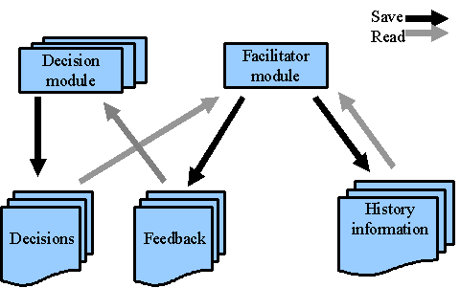
Figure 1: Structure of MOB and information flows between modules

Structure of player module
Decision making in the player module is distributed to the following Excel sheets:

- Prices for consumers
- Offers for corporations
- Marketing and R&D
- Network maintenance
- Purchasing
- Human relations management

Information directly related to decision making is shown in the same sheet as the decisions are made. Players can start the decision making from any of the sheets. In addition to the decision-making sheets player module has a separate sheet for financial information that holds all the necessary information regarding players’ financial status. There are also three sheets of more technical nature. One for holding the directory paths for the text files, which is used in communication between the player module and the facilitator module, and two for retrieving information from the text files. One of these sheets has the information concerning the team that plays with that particular player module (Results) and the other has information concerning all the teams (Shared info). Figure 2 illustrates the data flow in user module.

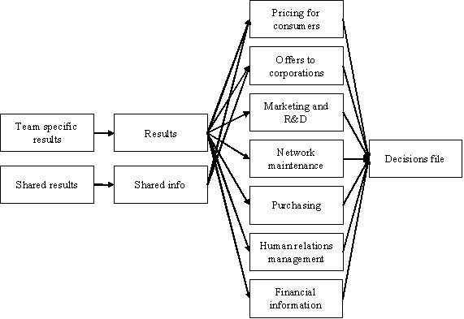
Figure 2: Data flow in player module

Structure of facilitator module
The generation of a new market situation in the facilitator module begins by reading in the decision of all teams. All decisions are first collected to one sheet, which is called “raw data”. From this sheet decision are spread according to their subject to sheets where the actual calculation of the new market situation is made. Calculation of the new market situation is distributed in the same manner that decision-making is distributed in the player module, see figure 3. There are two basic results from most of the calculations. First is an index telling the success of the players’ actions on a particular area and second is the costs incurred from the decisions. When calculations in all different areas are done the indexes are collected to the sheets: “Pricing for consumers” and “Offers for corporations”. Also demand information is collected on these sheets. Next sales, revenues and market shares of each team are calculated. Information about revenues and costs is collected to a separate sheet (see figure 3) where the new financial situations is calculated.

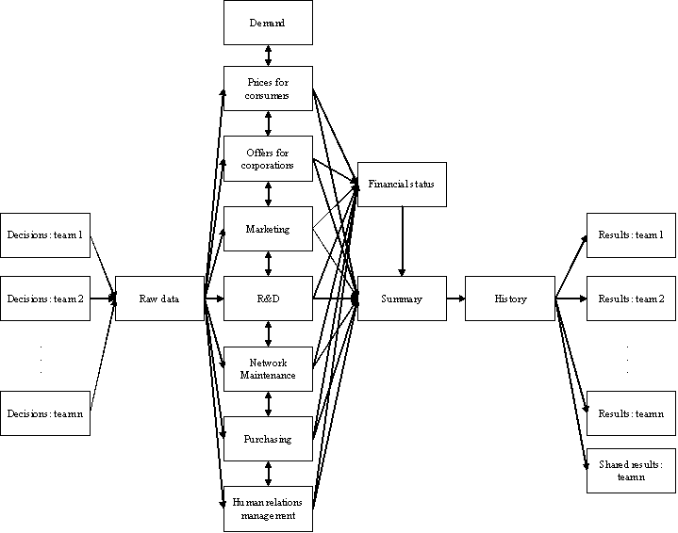
Figure 3: Data flow in facilitator module (simplified)

After all the steps described in the previous chapter are accomplished the new market situation is ready. All that is left is to summarize the valuable information, save it to the history sheet and distribute it to the players. Players do not get all the information that is saved in the history sheet. They get all the information concerning them and some selected information concerning their competitors.

Connections in the figure 3 are simplified in order to make the figure understandable. In real implementation many calculations use the history data in addition to data retrieved directly from the players. More detailed information about history related connections and also about vertical connections between the sheets is given in the following chapters.

Players’ module in mobile operator business game

This chapter describes in detail all decision screens that are used in the game.

Pricing for consumers
Voice traffic is priced in the same manner that mobile operators have traditionally priced it. All the players will have the same pricing scheme. See the upper part of figure X. It is recommended that players examine carefully their cost structure and estimate some kind of value for the lowest prices they can offer and still be profitable. Players should also estimate the highest prices customers are willing to pay. As in real life neither of these values is likely to be same between any two groups of players.

In data services players have an additional opportunity to differentiate and compete with the actual pricing scheme. See the middle part of figure 4. The players have three choices to choose from. Each of these choices has their own pros and cons. First alternative is usage-based prising, which is basically identical to the pricing scheme used in voice traffic. With this scheme traffic is measured constantly. Second pricing scheme is flat rate pricing. In this scheme customers pay a monthly fee, which gives them permission to use as much network resources, as they like. If players choose this pricing scheme they should be prepared for careless use of network resources. The third prising scheme is block pricing. This is a combination of usage-based pricing and flat rate pricing. The idea is that a consumer pays a monthly fee for block of data and if he uses more he pays usage-based fee for every data unit he uses.

The last consumer related pricing decisions are the prices for person-to-person messaging services. Players have to set prices to SMS and MMS messages. SMS market is considered to be a mature market. MMS on the other hand is a growing market where demand starts from zero and gradually grows during the game. MMS might partly satisfy the same needs as SMS. As demand for MMS grows there is likely to be a decline in the demand for SMS though MMS will never fully replace SMS.
.

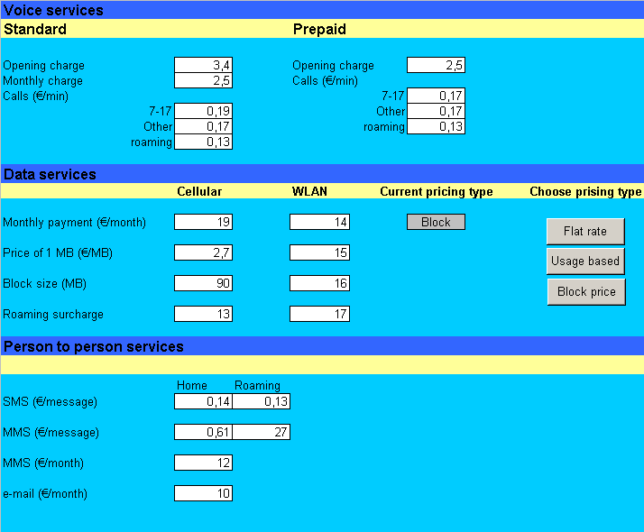
Figure 4: Decision screen for consumer pricing

Offers for corporations
Corporate customers are divided into three segments according to their size. Segments are: small and medium sized enterprises, national corporations and international corporations. An additional fourth segment is public administration. See figure 5. Decisions concerning public administration are the same as in corporate segments but the pricing rules are different. Generally profits in public administration are smaller than in corporate segments.
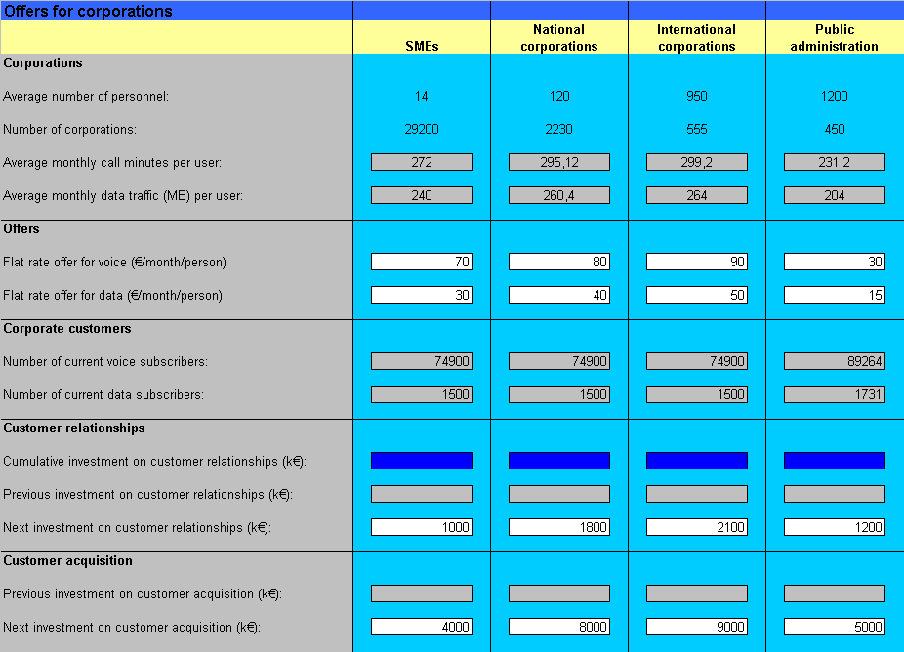
Figure 5: Decision screen for corporate pricing

Players can make offers to each of the previously mentioned segments. Offers are made as monthly flat rate charge per person. Following segment specific information helps in decision-making:

- Average number of personnel
- Number of corporations
- Average monthly call minutes per user
- Average monthly data traffic per user

The resource usage of each segment can be calculated from average number of personnel, number of current customers, estimations of new customers and monthly call minutes/data traffic per user. From resource usage the players can calculate the cost of these customers. This information can be used as the minimum price offer. For the actual offer the players have to consider the general price level between all competitors and their investment on customer relationships. If players have invested enough in customer relationships in the long term, customers might see their offer more valuable than a cheaper offer by some competitor who has not invested in customer relationships. Investment in customer relationships is the equivalent of marketing investment in consumer side. In corporate side the marketing is done individually to each customer. In addition to investing in customer relationships, players have to make decisions about acquiring new customers. Acquiring a new customer is about five times more expensive than retaining an old one [4].

From this sheet the players can directly see both the estimated revenues from corporate segments and the estimated direct expenses of corporate deals. Indirect corporate expenses such as personnel, equipment and administrative expenses are considered elsewhere. Players should be efficient in their investments. Too small investments will not produce the wanted revenue and thus can be considered as wasted capital. Too large investments will not produce any more revenues than investments of the right size and again money is wasted. Last thing that should be kept in mind is that customer relationships are a continuous long-term investment.

Marketing and R&D
Marketing decisions are divided into three different service categories: voice, data and content. The decisions are made using a top down approach. First players decide the size of their marketing budget. Then the budget is divided between service categories. When each service category has its part of the whole budget the marketing messages are targeted. See figure 6.

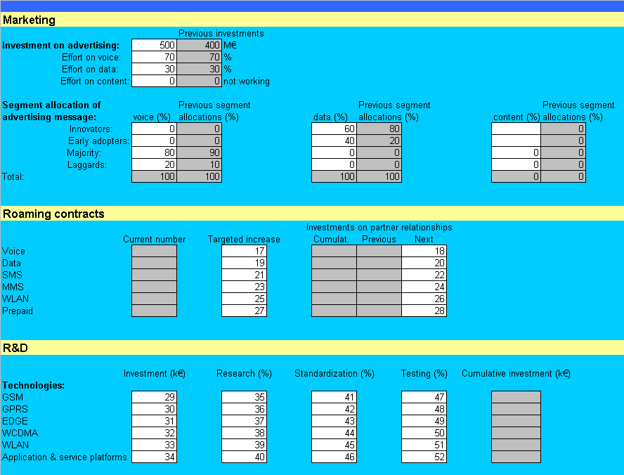
Figure 6: Decision screen for marketing

Customers are divided to four segments which all have different characteristics and sizes. The segments and their sizes as a percentage of the whole customer population are presented in the following list:

- Innovators, 2.5%
- Early adopters, 13.5%
- Maturity, 68%
- Laggards, 16%

This segmentation is adopted from reference [5].

Network maintenance
Network maintenance view is as much an information view as it is a decision view. In this view players can see the capacity, condition and usage-level of their network equipment (See figure 7). The view divides the network equipment into three logical entities: access network equipment, core network equipment and supplementary equipment. This kind of division is derived from 3GPP specifications [2][3].

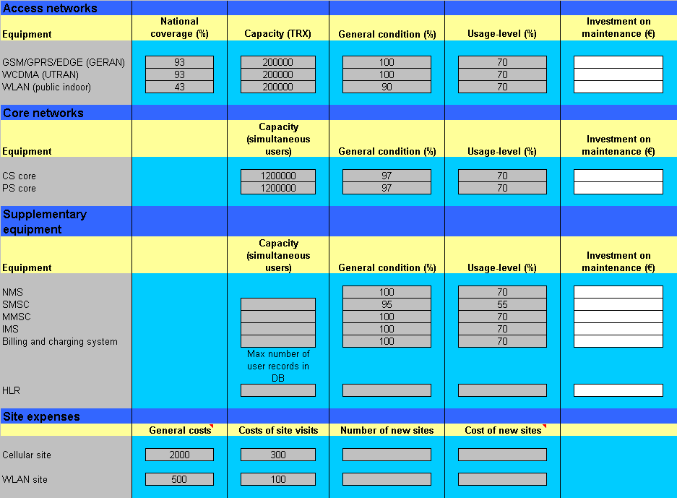
Figure 7: Decision screen for network maintenance

The decisions players have to make on this sheet are related to the condition of the network equipment. Players need to decide the financial effort they will put in maintenance of the equipment. When new technologies or services are taken in use, the network equipment experiences a shake down period before the new service or technology is working properly. This period lasts roughly one season and during this time the usage level of the network should not be raised very high. A good rule of thumb is that a good usage-level is about 70% of the theoretical maximum. If maintenance is done properly the fault conditions of the network is kept at minimum.

Conditions of network elements and usage-levels tell the level of quality delivered to customers. If customers receive services with poor quality, they are willing to pay less for the service and also more willing to change the operator.
In addition to maintenance information this view gives information regarding purchase decisions. Players should always make sure that the capacities of their network equipment are sufficient to serve all their customers.

